Prototype Concept & Feature Description   
Spotify

# Download Instructions

* Clear and easy to follow instructions on how to download and input your data into PriOSS

# Navigation Menu

* Collapses to the side, hiding the texts and only showing a narrow column with Icons for the menu items
* “Home”, “About”, “Contact” & “Remove data-download” menu items

# Dashboard

* There are some visualization previews in the form of different tiles at the top of the page, they are headed by the label “Your data”
* Below the tiles is a second tile area headed by the label “Frequently Asked Questions” containing tiles that each contain one question, like
  + “For what purposes does Spotify use my data?”
    - Click leads to Purposes-Page
  + “What rights do I have in regard to my personal data?”
    - Click leads to Rights-Page
  + “How can I erase my personal data from Spotify?”
    - Click leads to Erasure-Helper
  + etc.

They each link to an information page that educates the user about the respective question

* Visualization Tiles
  + Top Artist
    - Shows your most listened artist
    - Click leads to artists visualization
  + Top Song
    - Shows your most listened to song
    - leads to songs visualization
    - Show if saved under liked songs
  + Top Genre
    - Most listened to genre
    - Click leads to Genre Visualization
  + Top Album
  + Average Song Mood
    - Shows preview of the average song mood you listened to
    - Clicks leads to mood visualization
  + Privacy Settings Display
    - A Preview of your current privacy settings / recommendations on where what settings can be changed for the respective services
    - Contains Alert user if many inferences are present in the Spotify data since this can be a sign of active facebook linking.
    - A Click leads to the Privacy Settings Center
  + Spotify Thinks you are…
    - Preview of inferences
    - Click leads to inferences list
  + Listening Time preview
    - How much did you listen during the most recent week present in the datadownload, how much on average per day?
    - Click leads to listening time visualization
  + Search Queries
    - Click leads to Search Queries
* An interactive tutorial that highlights specific aspects and gives an overview of the features of the dashboard when the user visits the dashboard for the first time

The Dashboard could look something like this:  
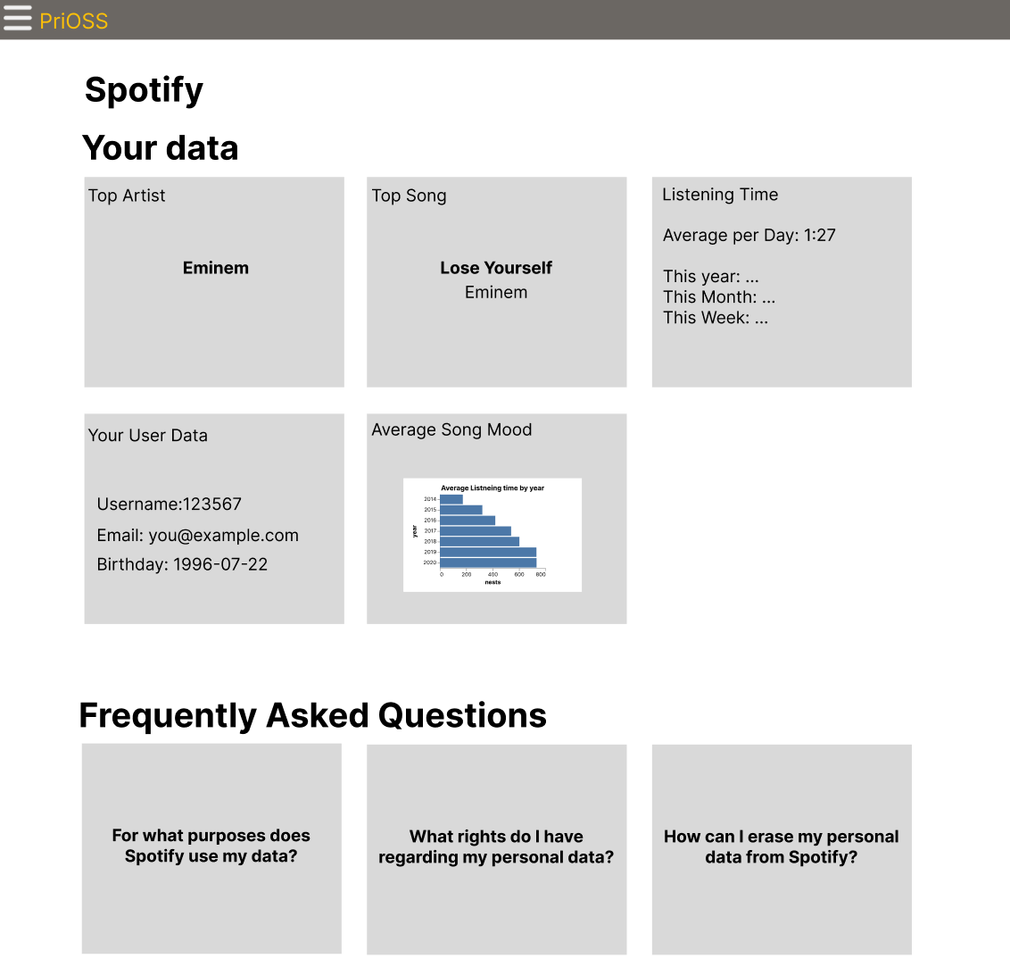

# User Data

* A list of User Data (e.g. Email, Birthday, Postal Code), Family Plan, Payment Data, Follow, Platforms (e.g., Android, Windows; from Search-Queries-File), (Spotify for artists)

# Artists Visualization

* Either a table of the artists that you listened to, with information like total listening time
* Or a barchart showing how much time was spent listening to the specific artists
  + One bar is either: hour/day/weeks/months/years (configurable)  
    This means there are different views that either show the hours within one day, the days during a week, the days inside a month, the months inside a year or the years inside a decade
  + A single bar shows how much time of the day/hour/etc. was spent listening, it is subdivided into how much of that time was spent listening to which specific artists
  + When you click on a single bar, you jump into the detailed view of the time period this bar represents

# Songs Visualization

* The songs that you listened to
* Most listened songs
* Which category (Request necessary)
* How many hours in time frame
* Can filter morning/evening/night & Specific Days (e.g. to show it only for mondays)

# Genre Visualization (Request necessary)

* Shows which genres were listened to by time
* Similar to listening time visualization (see below)

# Mood Visualization

* Multi-Color barchart showing the mood attributes of the average inside a certain period
* Default maybe last 30 days (Could help with performance)
* One bar is either: hour/day/weeks/months/years (configurable)  
  This means there are different views that either show the hours within one day, the days during a week, the days inside a month, the months inside a year or the years inside a decade
* When you click on a single bar, you jump into the detailed view of the time period this bar represents

# Listening Time Visualization

* Barchart showing how much time was spent listening during a configurable time period.
* One bar is either: hour/day/weeks/months/years (configurable)  
  This means there are different views that either show the hours within one day, the days during a week, the days inside a month, the months inside a year or the years inside a decade
* When you click on a single bar, you jump into the detailed view of the time period this bar represents
* When visualizing a whole day, little icons in the background of the chart show what time of day (morning, noon, evening, night) the times belong to

# Inferences List

* Filterable and searchable
* Inferences shown in clearer format
* Explanations for what different inferences mean
* Includes a rectification mechanism by selecting items and generating an email to Spotify from them

**Search Queries**

* Most searched artist/album/song (request necessary)
* Filterable List of used search queries in Spotify’s search
* Top search terms

# Privacy Settings Center

* Shows your current privacy settings / recommendations on where what settings can be changed for the respective services, possibly realized as an interactive survey
* Contains Alert if many inferences are present in the Spotify data since this can be a sign of active facebook linking. The user should be able to disable the alert if the do not find it helpful or it does not apply to them

# Purposes-Page

* Explains for what purposes Spotify says that it uses your data

# Rights-Page

* Explains in simple terms what rights the GDPR grants users in regards to your personal data

# Erasure-Helper

* Explains what options one has to erase data from Spotify